**Project Report**

On

**Online Resume Builder System**

For the partial fulfillment of the degree in

**Bachelor of Computer Application**



**Guided by:** **Submitted by:**

Dr. Naveen Tewari 1. Amit Kumar

2. Anjali Jalal

3. Deepak Joshi

4. Kritika Pant

5. Kusum Pargain



**Faculty of Computer Science Applications**

**Amrapali Group Of Institutes**

Software Requirement Specification

TABLE OF CONTENT

Page Nos.

1. Introduction 4

1.1. Purpose

1.2. Scope

1.3. Definitions, Acronyms, and Abbreviations

1.4. References

1.5. Overview

2. The Overall Description 7

2.1. Product Perspective

3.7.1 System Interfaces

3.7.2 Interfaces

3.7.3 Hardware Interfaces

3.7.4 Software Interfaces

3.7.5 Communications Interfaces

3.7.6 Memory Constraints

3.7.7 Operations

3.7.8 Site Adaptation Requirements

2.2. Product Functions

2.3. User Characteristics

2.4. Constraints

2.5. Assumptions and Dependencies

3. Specific Requirements 12

3.1. External Interfaces

3.2. Functions

3.3. Performance Requirements

3.4. Logical Database Requirements

3.5. Design Constraints

3.6. Software System Attributes

3.7.1 Reliability

3.7.2 Availability

3.7.3 Security

3.7.4. Maintainability

3.7.5 Portability

3.7. Organizing the specific Requirements

3.7.1 System Mode

3.7.2 User Class

3.7.3 Objects

3.7.4 Features

3.7.5 Stimulus

3.7.6 Response

3.7.7 Functional Hierarchy

4. Document Approvals 18

5. Supporting Information 19

1. **INTRODUCION**

Resume is the first meeting between you and a prospective employee more often now than ever. So, how do you want to be remembered? Companies do not have the time to interview every applicant that is interested in the job. If they did, there would not be a company to work for. They use eliminating process. That’s right –resumes.

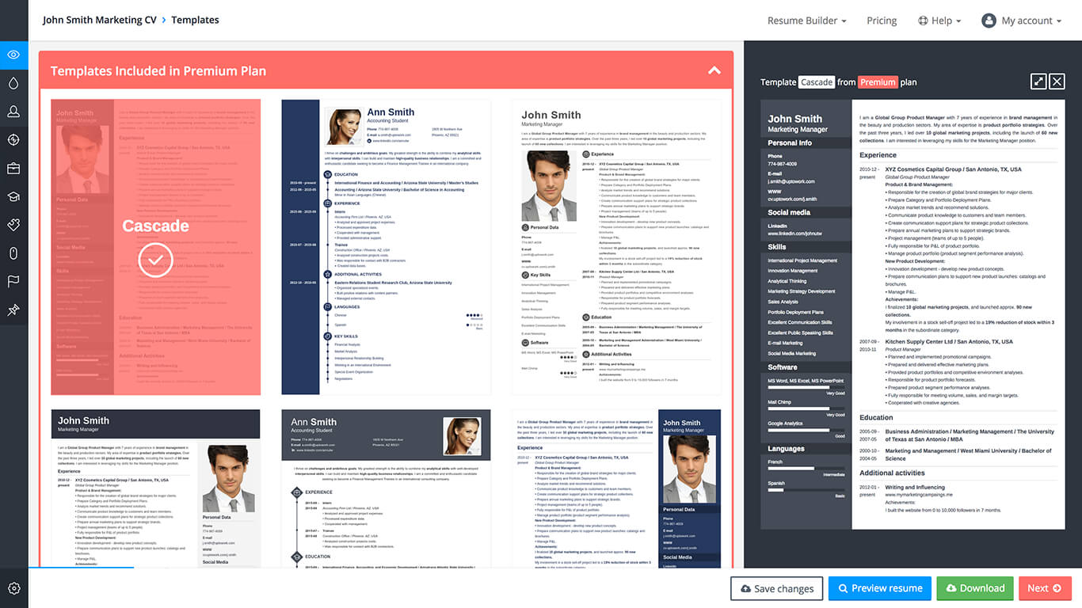

* 1. PURPOSE

Many resume development agencies offer resume evaluation services wherein they evaluate the resume and suggest any necessary changes. Candidates are free to either do those change themselves or may take help of the agency itself.

A resume is a marketing tool in which the content should be adapted to suit each individual job application and/or applications aimed at a particular industry.

When a job seeker wants to apply for a job online then generally he/she needs to attach his/her resume with the email.

The main objective of our project is to fulfill the above mentioned requirement that is to provide the recruitment management team of our college with all the information of students before the starting of placement session which will help them to sort out the list of students according to the demand of the placement company.

The second objective of our project is to generate resumes of students in a predefined format. When students enter in the last semester of their respective fields then the students get highly attentive towards their placements sessions. But before appearing in the placements session students should have their proper resume, as resume goes before the student and reflects academic performance, skills and other attributes.

* 1. SCOPE
* In future we will develop this software in the form of mobile app so that it could be used online as well offline mode.
* Companies can be added in this software so that they can directly fetch the resume of the candidate from one platform.
* Company’s information can be shared with job applicants.
* Mobile communication (message) can be added later on, for authentication and interview purposes.
* One advantage for employers to online resumes is the significant cost saving compared to traditional hiring methods.Another is that potential employers no longer have to sort through massive stacks of paper.
* A good resume is your passport to a better job.  
  Create your professional resume now and get more job interviews.
* Our project basically deals with generating a very effective resume that contain all the information of a student in a pre-defined format which is needed during placement session
  1. DEFINITION

A resume is a document used by a person to present their backgrounds and skills. Resume can be used for a variety of reasons, but most often they are used to secure new employment.

The resume is usually one of the first items, along with a cover letter and sometimes an application for employment, which a potential employer sees regarding the job seeker and is typically used to screen applicants, often followed by an interview.

As has been indicated above, the word résumé comes from the French word resume meaning "summary".

* 1. OVERVIEW

SRS will include two sections:

**Overall Description** will describe major components of the system, interconnection and external interfaces.

**Specific Requirements** will describe the functions of actors, their role in the system and constraints.

1. **THE OVERALL DESCRIPTION**

In many contexts, a resume is typically limited to one or two pages of size A4 or letter-size, highlighting only those experiences and qualifications that the author considers most relevant to the desired position. It is usually, therefore, more sensible to optimize the resume for each position applied for and its keywords. In order to keep track of all experiences, keeping a 'master resume' document is recommended, providing job-seekers with the ability to customize a tailored resume while making sure extraneous information is easily accessible for future use if needed.

The complexity or simplicity of various resume formats tends to produce results varying from person to person, for the occupation, and to the industry.

Describe the general factors that affect the product and its requirements.

* 1. PRODUCT PERSPECTIVE

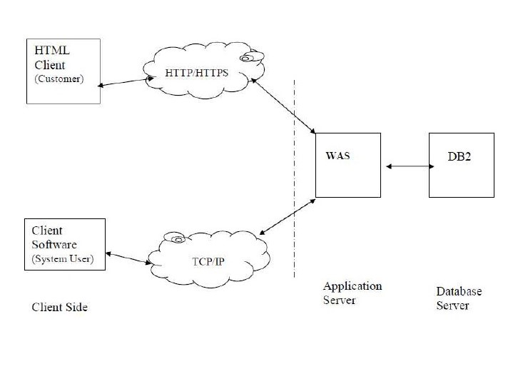

* The web pages (XHTML/JSP) are present to provide the user interface on customer clientside. Communication between customer and server is provided through HTTP/HTTPS protocols.
* The Client Software is to provide the user interface on system user client side and for this TCP/IP protocols are used.
* On the server side web server is for EJB and database server is for storing the information.
  + 1. HARDWARE INTERFACE
    - Processor : Pentium / Dual Core / AMD/Core2Duo
    - Ram : 1GB
    - Color monitor
    - Keyboard
    - Mouse
    - Printer etc.
    1. SOFTWARE INTERFACE
  + Operating System Windows XP or above
  + Front End Html Css (Bootstrap).
  + Backend MyPHPadmin(XAMP), My Sql
    1. COMMUNICATION INTERFACE

* Client on Internet will be using HTTP/HTTPS protocol.2.
* Client on Intranet will be using TCP/IP protocol.
  + 1. MEMORY CONSTRAINT

Minimum memory of 512MB is required to run the exe file without any lags. constraint does not possess an issue now a days as the minimum present RAM in a common system is 1GB.

* 1. PRODUCT FUNCTION
* Login Module
* Registration Module
* Personal Info. Module
* Academic Info Module
* Skill Info
* Contact Info
* Resume Info
* Professional Info
  1. USER CHARACTRISTICS

Every user should be comfortable of working with computer andnet browsing. He must have basic knowledge of English too.

2.4 CONSTRAINTS

* GUI is only in English.
* Login and password is used for identification of customer and there is no facility for guest.
* This system is working for single server.
* There is no maintainability of back up so availability will get affected.
* Limited to HTTP/HTTPS
  1. ASSUMPTION AND DEPENDENCIES

* The details related to the product, customer, payment and service transaction provided manually.
* Administrator is created in the system already.
* Roles and tasks are predefined

1. Specific Requirements

3.1 FUNCTIONS

3.1.1 USE CASE DIAGRAM



Administrator



User

3.2 PERFORMANCE REQUIREMENTS

* The overall system should be fast and error free.
* It should have built in error checking and correction facilities.
* The system should be able to handle large amount of data comfortably.
* **User Satisfaction: -**The system is such that it stands up to the user expectations.
* **Response Time: -**The response of all the operation is good. This has been made possible by careful programming.
* **Error Handling: -**Response to user errors and undesired situations has been taken care of to ensure that the system operates without halting.
* **User friendliness: -**The system is easy to learn and understand. A native user can also use the system effectively, without any difficulties.
* **Safety and Robustness: -**The system is able to avoid or tackle disastrous action. In other words, it should be foul proof. The system safeguards against undesired events, without human intervention.

3.3 LOGICAL DATABASE REQUIREMENTS

* DATABASE DESIGN (ER- DIAGRAM AND TABLE)



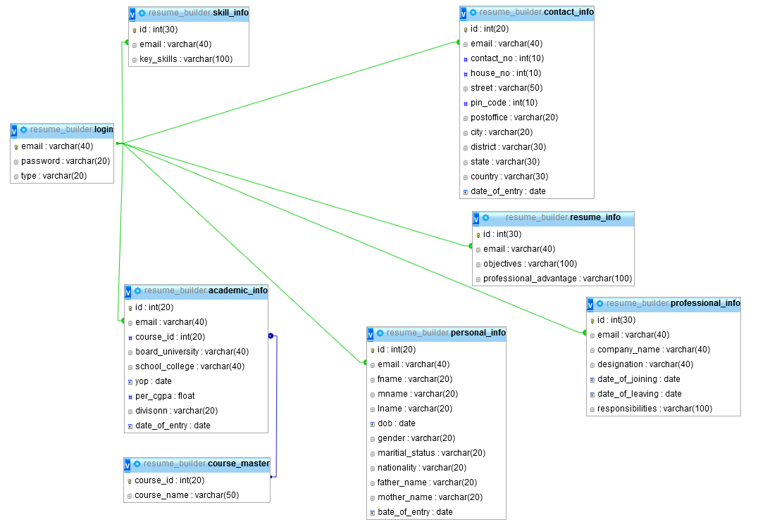

3.4 DESIGN CONSTRAINTS

There are a number of factors in the client’s environment that may restrict the choices of a designer. Such factors include standards that must be followed, resource limits, operating environment, reliability and security requirements and policies that may have an impact on the design of the system. An SRS (Software Requirements Analysis and Specification) should identify and specify all such constraints.

* **Standard Compliance: -** This specifies the requirements for the standards the system must follow. The standards may include the report format and scheduling properties.
* **Hardware Limitations :-**The software may have to operate on some existing or predetermined hardware, thus imposing restrictions on the design. Hardware limitations can include the types of machines to be used, operating system available on the system, languages supported and limits on primary and secondary storage.
* **Reliability and Fault Tolerance: -** Fault tolerance requirements can place a major constraint on how the system is to be designed. Fault tolerance requirements often make the system more complex and expensive. Requirements about system behavior in the face of certain kinds of faults are specified. Recovery requirements are often an integral part here, detailing what the system should do I some failure occurs to ensure certain properties. Reliability requirements are very important for critical applications.
* **Security: -**Security requirements are particularly significant in defense systems and database systems. They place restrictions on the use of certain commands, control access to data, provide different kinds of access requirements for different people, require the use of passwords and cryptography techniques and maintain a log of activities in the system.
  1. SOFTWARE SYSTEM ATTRIBUTES

3.5.1. Reliability

* The reliability of the overall project depends on the reliability of the separate components. The main pillar of reliability of the system is the backup of the database which is continuously maintained and updated to reflect the most recent changes. Thus the overall stability of the system depends on the stability of application and its underlying windows operating system.
  + 1. Availability
* The system should be available at all times. In case of a of a hardware failure or database corruption, a replacement page will be shown. Also in case of a hardware failure or database corruption, backups of the database should be requested by the operator. Then the service will be restarted. It means 24 x 7 availability.
  + 1. Security
* The system’s back-end servers shall only be accessible to authenticated management.
* It should give access to the registered administrator/user only.
  + 1. Maintainability
* In case of a failure, a re-initialization of the project can be done.
* Also the software design is being done with modularity in mind so that maintainability can be done efficiently.
  + 1. Supportability
* The code and supporting modules of the system will be well documented and easy to understand. User Documentation and Help System Requirements.